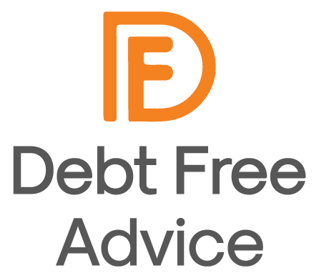



Debt Free Advice is a partnership of charities working

together to provide free, impartial money advice. Each year,

we support over 20,000 people with their debt

and money worries who rate us as “Excellent” on Trustpilot.

The records we keep are for the use of this Debt Free Advice only. We will not tell anyone about your enquiry and we

will not pass any information on to any third party without your permission. The funder and their agencies may from

time to time assess our work to ensure we are providing a high quality of advice (if you do not wish your files to be

checked by our funders please let your advisor know).

Confidentiality and consent…

✓

Our service is always free at the point of delivery to

clients. This is possible as our advice is fully funded

by the Money and Pensions Service

✓

We will help you to explore your debt problem

✓

We will complete an income and expenditure form to

understand your finances

✓

We will look for ways to increase your income and

reduce your outgoings

✓

We will explain the debt options you have and how

they will a

ff

ect you

✓

We will keep you informed of any action we take and

the progress of your enquiry

What you can expect from us:

✓

You will attend all appointments we arrange for you

(

or let us know as soon as possible if you cannot)

✓

You will let us know if there is a change in your

circumstances that may a

ff

ect your case (such as

you lose your job, someone joins the family, you

move home)

✓

You will provide all information and evidence that

your advisor asks. For example; evidence of your

income, spending and debts - failure to do so may

mean our advice is not correct.

✓

If you have an advisor acting on your behalf, you will

not negotiate directly with creditors before

discussing it with your advisor

✓

You will not borrow more money or enter into a new

credit agreement

✓

If you do not wish us to act on your behalf you will

tell us you no longer need our help

What we expect from you:



In some circumstances we may refer you to another agency for further help. This may be within the same service we

provide or outside of it. We only refer and signpost to agencies that have a good record of providing a high quality of

service.

Referral and signposting…

Wherever possible we will give you the information and resources you need to resolve your debt problem. If the

complexity of the problem, or your personal situation, means you are not able to deal with every aspect of your case,

we may be able to provide ongoing support for the issues with which you need our help.

Your advisor will help you access a debt solution, guide you to self-help material enabling you to resolve your issues,

or refer you to another agency who is best equipped to help you.

Our help may not stop some of the creditors’ actions and whilst we are supporting you, Creditors may continue to

add interest and charges to your debt.

Your credit rating could be a

ff

ected if you enter into a payment arrangement or insolvency solution.

Your advisor may agree actions with you, it is your responsibly to complete these.

Please note…

We will close your case if:

✓

A strategy we have assisted you with is up and running

successfully

✓

You disengage with the advice process

✓

You advise us that you no longer need our assistance

✓

We have provided you with advice and directed you to available

resources

✓

We have referred you to another organisation to help you further

✓

We are not able to provide a service to you

Case closure…

Do you need any extra help, for

example, sign language, large print

or an interpreter service?

If so, please let your advisor know.

If you have any questions about the

content of this information sheet,

please speak to your advisor

Extra help…



Our advice service is authorised and regulated by the Financial Conduct Authority (FCA). If you are not happy with

the service provided to you, please follow our complaints procedure which can be found at

www.debtfree.london/complaints

If you are not happy with our final response, you can take your complaint to the Financial Ombudsman Service.

Further information can be found at www.financial-ombudsman.org.uk.

Financial Conduct Authority and complaints…



Contact us…



Give us a call…

0800 808 5700

Drop us a WhatsApp message…

0800 808 5700

Use our web chat service…

www.debtfreeadvice.com

Find us on Facebook

@DebtFreeAdviceUK